**Creating skills and assistant for Chatbot**

**Chatbot Skills Creation**

| **Date** | **10 November 2022** |
| --- | --- |
| **Team ID** | **PNT2022TMID13205** |
| **Project Name** | **Ai Based Discourse For Banking Industry** |

**Greetings**

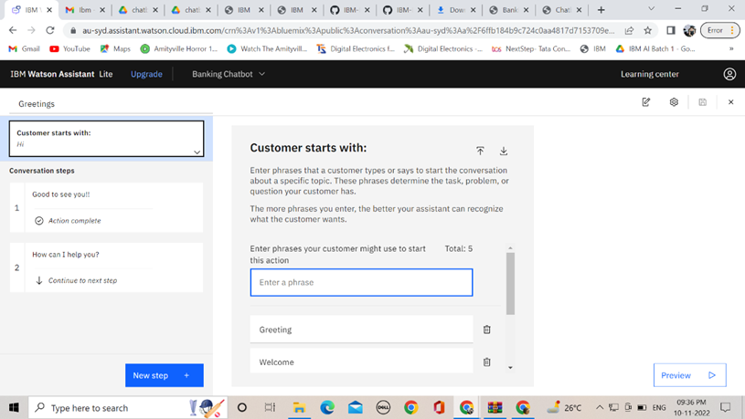

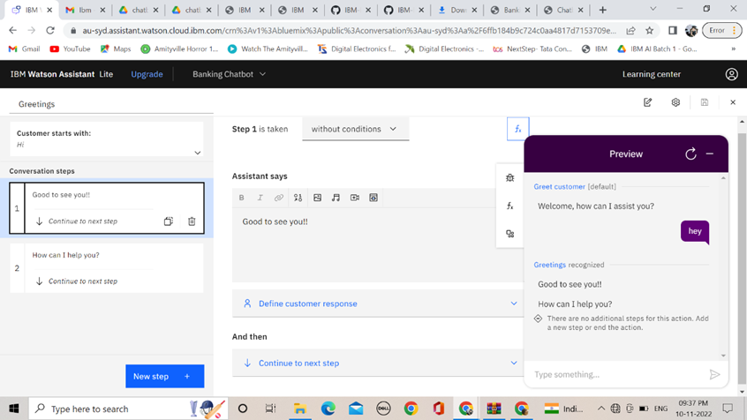

**Fall Back**

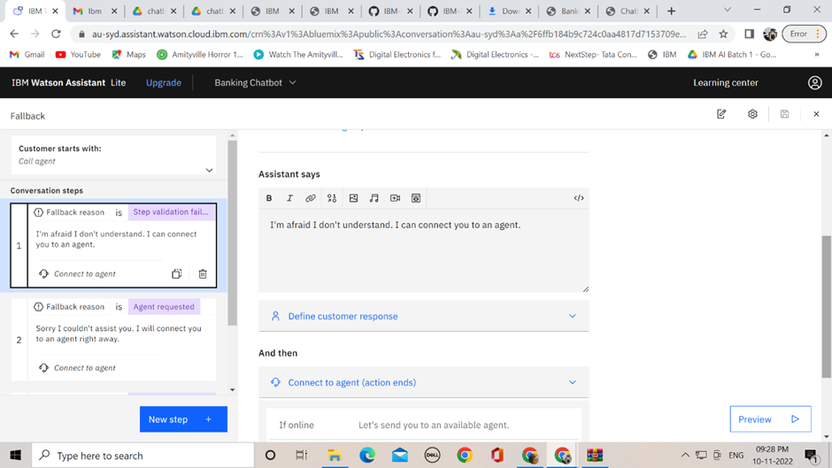

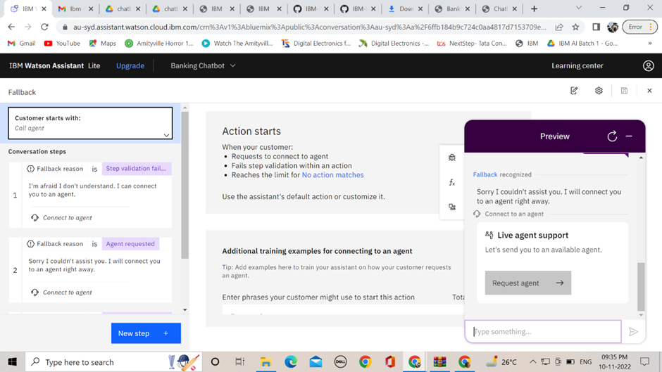

**End Greetings**

